**Data analysis and Data visualization**

**for New York City Airbnb open data 2019 in R**

Pengfei Ma

Boston University

CS 544

Prof. Heather

Oct.12th 2020

**Abstract**

As a travel lover, traveling on vacation is the most exciting thing. From eastern coast to California, from Texas to Yellowstone. Road trip and flights are two major ways to arrive the city. However, no matter which way to travel, housing need to be considered in both two travelling. Nowadays, a lot of housing websites came out, a very attractive housing application named Airbnb is very popular. Analyzing the open data from Airbnb would be really useful for the future travelling and could know a city much better.

This paper will collect all the steps of data analyzing of New York City Airbnb 2019 open data by R. Explaining the methods and collecting all the results. The steps of analyzing in this project is importing data, analyzing data, reflecting the results and conclusion. This project will use regular statistic data such as mean, standard deviation, distributions and strata in statistic to do the calculation. In addition, this project will use sum(), srswr(), inclusionprobabilities(), UPsystematic(), strata() functions in R code as the main body. “plotly” and “sampling” are the packages used in this project as well. Eventually, plotting method: barplot, plot, pie, histogram in R will be used to do the data visualization. The conclusion of the projects will be the reflection based on the analyzing results above. RStudio will be the only one IDE used for all calculation and plotting in this project.

The major columns used in this project is the “neighborhood_group”, “price”, and “number of reviews”. And the goal of this project is exploring three information, three relationships and sampling for the data. Three information that want to be obtained is:

1. How many airbnbs in each borough, which has the most and which has the least?
2. Which borough has the highest price and which has the lowest?
3. What are their proportions?

The three relationships that this project want to explore is:

1. The relationship between price and location.
2. The relationship between price and minimum nights
3. The relationship between price and its location.

Three information exploration will use statistic calculation, probability functions to gain the result. Three relationships will use probability density function (PDF), cumulative density function (CDF), distribution analysis, and central limit theorem (CLT) to concern these relationships. Finally, the application of sampling on Airbnb open data will use sample random sampling, systematic sampling, inclusion probability and strata to show the result.

*Keywords: Statistic functions, Plotting, RStudio, PDF, CDF, sampling, CLT*

**Project map**

Preparing the data

1. Picking the data set
2. Importing data

Data analyzing

1. Categorical variable analysis of the number of airbnbs in different boroughs in NYC
2. Setting data
3. Visualization of airbnbs in each borough

* Barplot of the number of airbnbs in each borough in NYC
* Pie chart for the proportion of airbnbs in each borough

1. Numerical variable analysis of the price of airbnbs in NYC
2. Setting data
3. Visualization for the price

* Barplot of the frequency of the price
* Barplots of the frequency of the price in each borough
* Summaries of the price in each borough
* Boxplots of the price in each borough in one diagram

1. Comparation of the relationship between price, minimum night, number of reviews
2. Pairs diagram of the combination of the relationship of three variables
3. Scatterplot of the relationship of price and minimum night
4. Scatterplot for the relationship of price and number of reviews
5. Boxplots of price, minimum nights, and number of reviews
6. Distribution Analysis
7. Plotting the data of number of reviews in airbnb open data
8. Scatterplot for the probability of each number of reviews appeared
9. Boxplot of the number of reviews
10. Summary of the number of reviews and its standard deviation
11. Probability density function for the number reviews as normal distribution
12. Cumulative distribution function for the number reviews as normal distribution
13. Applicability of the Central Limit Theorem for Price
14. Setting data
15. Central Limit Theorem visualization for price

* Histogram for CLT of sample size 10, 20, 30, 40 for price

1. Central Limit Theorem visualization for each borough

* CLM for Manhattan
* CLM for Brooklyn
* CLM for Bronx
* CLM for Queens
* CLM for Staten Island

1. Sampling for airbnb open data
2. Setting data
3. Sample random sampling

* Table of 5000 random variables drew in airbnb
* Barplot of 5000 random variables drew in airbnb
* Table of proportion of random variables drew in each borough
* Pie chart of the proportion of random variables drew in each borough

1. Systematic sampling

* Table of systematic sampling with size = 5000 for each borough
* Barplot of systematic sampling with size = 5000 for each borough
* Table of the proportion of systematic sampling with size = 5000 for each borough
* Pie chart of the proportion of systematic sampling with size = 5000 for each borough

1. Inclusion probability

* Table of inclusion probability
* Barplot of inclusion probability
* Table of the proportion of inclusion probability of the number of airbnbs
* Pie chart for the proportion of inclusion probability of the number of airbnbs

1. Stratified

* Setting data
* Table and description of stratified

Conclusion

References

**Preparing the data**

1. Picking the data set

Based on the choices of the data set, this project decided to choose Kaggle ([*https://www.kaggle.com/datasets*](https://www.kaggle.com/datasets)*)* as the resource of data website. The New York City Airbnb Open Data by author *Dgomonov* which was updated in 2019 will be considered as the primary data set in this project. The AB_NYC_2019.csv file is the only data file used in this project.

1. Importing Data

Firstly, downloaded the *AB_NYC_2019.csv* file from [*https://www.kaggle.com/dgomonov/new-york-city-airbnb-open-data?select=AB_NYC_2019.csv*](https://www.kaggle.com/dgomonov/new-york-city-airbnb-open-data?select=AB_NYC_2019.csv)into one folder on desktop named CS544_project. Then created a new R script in the same folder. Then, setting the path of the R script by the code

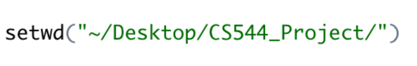

Moreover, importing data and assigning data to name “airbnb” by



Setting the packages (plotly, sampling) that will be used in this project

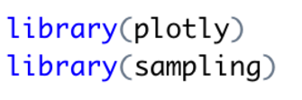

By using R code

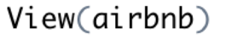

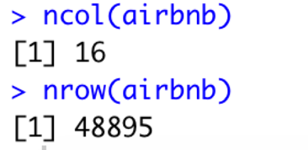

It could be clearly seen that there are 16 columns in airbnb and provide detailed information about the data. 16 columns are “id”, “name”, “host_id”, “host_name”, “neighborhood_group”, “neighborhood”, “latitude”, “longtitude”, “room_type”, “price”, “minimum_nights”, “number_of_reviews”, “last_review”, “reviews_per_hour”, “calculated_host_listing_count”, “availability_365”.

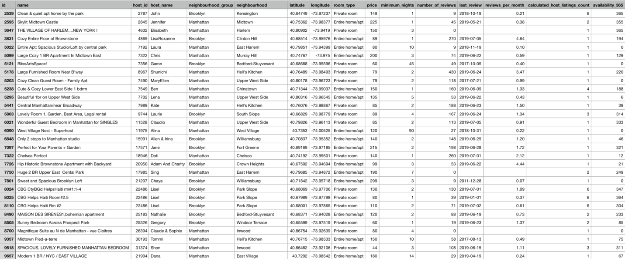

The airbnb file provide the details of the airbnbs in 5 boroughs of New York City (Manhattan, Brooklyn, Bronx, Queens, Staten Island) with total 48895 airbnbs. The most attractive information in this data file is the price and number of reviews. Also, these two columns of data are the most related to a customer.

**Data analyzing**

1. Categorical variable analysis of the number of airbnbs in different boroughs in NYC
2. Setting data

Firstly, assigning the number of airbnbs in different boroughs with the name of boroughs in NYC to “names_groupsInNYC”.



Secondly, gaining only the number of airbnbs in each borough and assign it to “numberOfAirbnbs”.



Finally, calculating the proportion of the number of airbnbs in the whole NYC, and assign to name “proportionEachBoroughs”.



1. Visualization of airbnbs in each borough

* Barplot of the number of airbnbs in each borough in NYC

Assigning the barplot to name “group_plot_number”, and added the number above the bar of the plot.

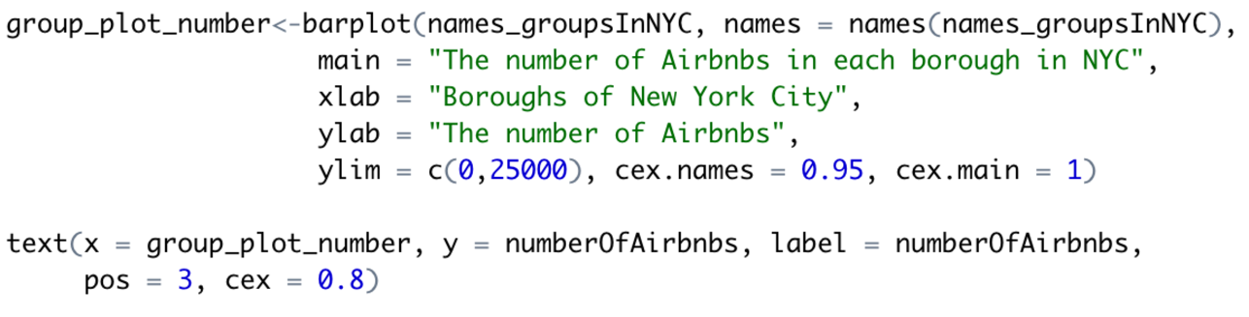

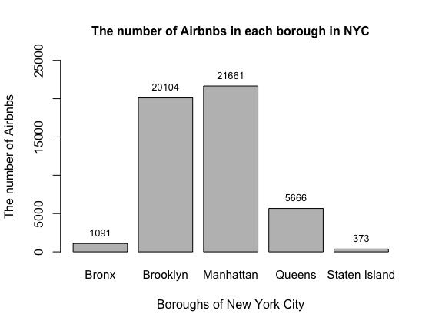

From the barplot above, it clearly shows that Manhattan has the greatest number of airbnbs in the whole NYC, which has 21661 airbnbs. Conversely, Staten Island has the least number of airbnbs, which is 373 airbnbs.

* Pie chart for the proportion of airbnbs in each borough

At first, creating the labels of the proportion. Assigning it to name “percent_labels”

Secondly, creating a pie chart and assign it to name “group_plot_percent”

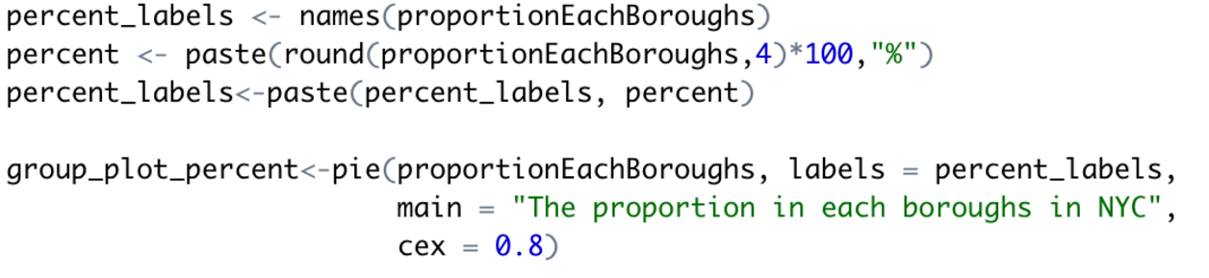

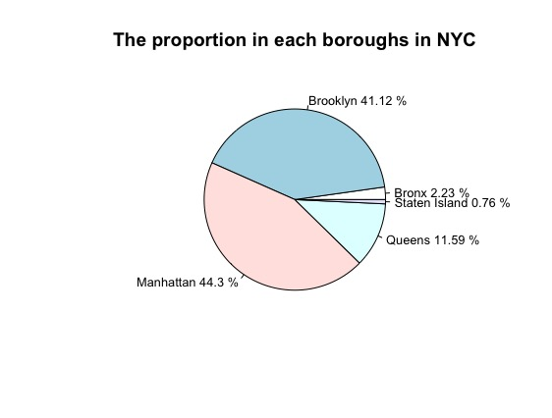

From the pie chart of the proportion of airbnbs in each borough in NYC, Manhattan occupied the most percentage of the number of airbnbs which is 44.3%. Brooklyn is NO.2 which has 41.12%. Queens has 11.59%. Bronx has 2.23%. And Staten Island has the least percentage, which is 2.23%.

1. Numerical variable analysis of the price of airbnbs in NYC
2. Setting data

Creating the subset of 5 boroughs (Manhattan, Brooklyn, Bronx, Queens, Staten Island) and assign them to names “manhattan”, “brooklyn”, “bronx”, “queens”, “staten”.

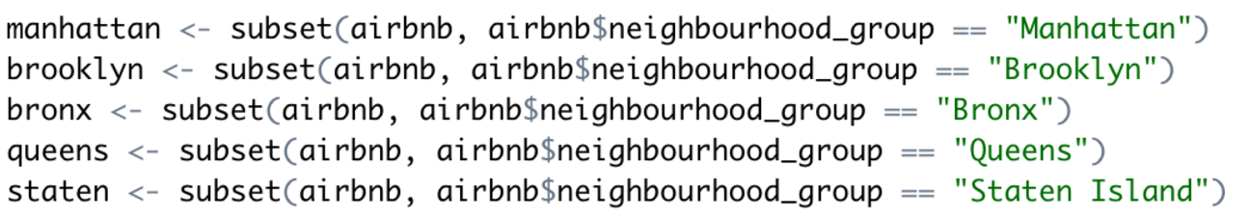

1. Visualization for the price

* Barplot of the frequency of the prices

By using table to get the frequency of each number in price and apply into barplot function to see the frequency of prices.



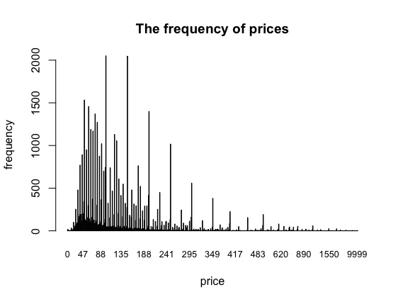

The barplot of the frequency of prices determined that most prices are concentrated on the interval 0 to 188. It could be separated to three intervals. [0, 88), [88, 188), and [188, 10000). From the diagram, the frequencies in the interval [0, 88] are higher than other intervals. This could imply that the price of most airbnbs are in [0, 88].

* Barplots of the frequency of the price in each borough

By using barplot functions to each subset. Assigning them to one diagram.

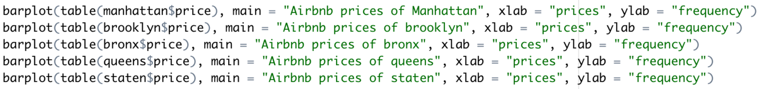

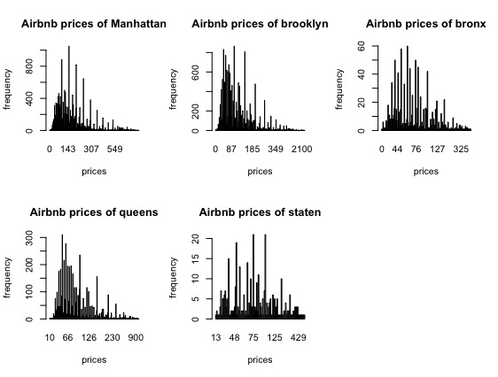

From the barplot of Manhattan, it shows that most prices located in the interval [0,143]. In the barplot of Brooklyn, most prices located in the interval [0,87]. In the barplot of Bronx, most prices are in the interval [0,76]. In the barplot of Queens, most prices are in the interval [10, 96], which 96 is the middle number of 66 and 126. In the barplot of Staten Island, most prices are in the interval [48,125]. From the combination of these five barplots, the assumption came out is that Manhattan has the highest price of airbnbs and Bronx has the lowest price. However, the information showed so far cannot provide an accurate result. Therefore, by applying summary function to these five data will provide statistic result to determine the assumption, which is more accurate and reliable.

* Summaries of the price in each borough

Applying summary function to each price column in each subset to gain six important statistical data to prove the assumption.

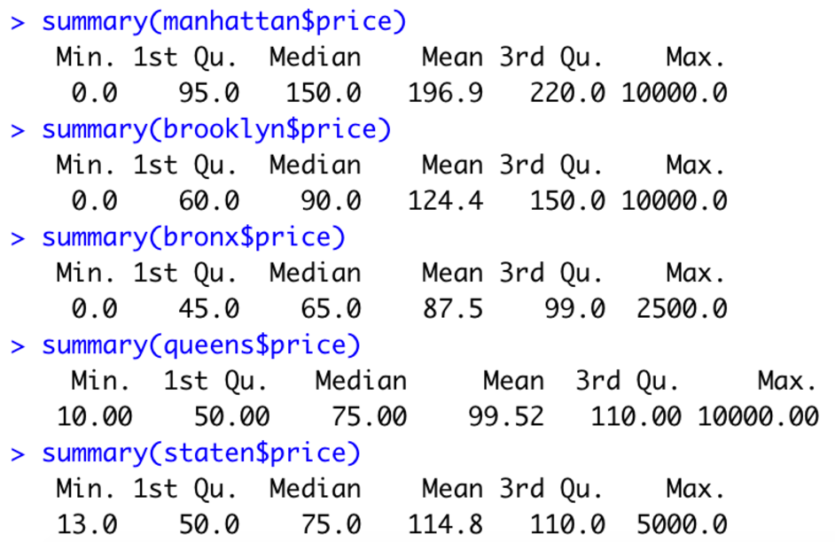

From five summaries above, by looking at the means of each summary. Manhattan has the highest mean, which imply that the average price of airbnb in Manhattan is the biggest. Conversely, Bronx has the lowest average price. Moreover, by looking at the median of each summary, it maintains the same results that Manhattan has the largest number and Bronx has the lowest. Based on all statistical information obtained above. The assumption was proved that Manhattan has the highest airbnb price, and Bronx has the lowest.

* Boxplots of the price in each borough in one diagram

By using package “plotly”, do the data visualization. Combining boxplots of five columns of the data into one diagram to see their quantiles, outliers, and six statistical data.

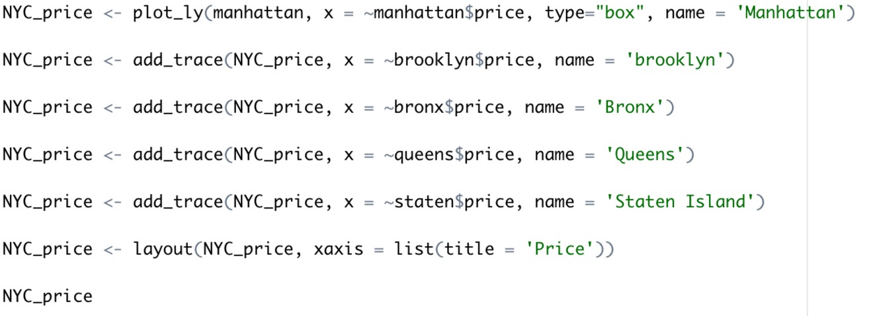

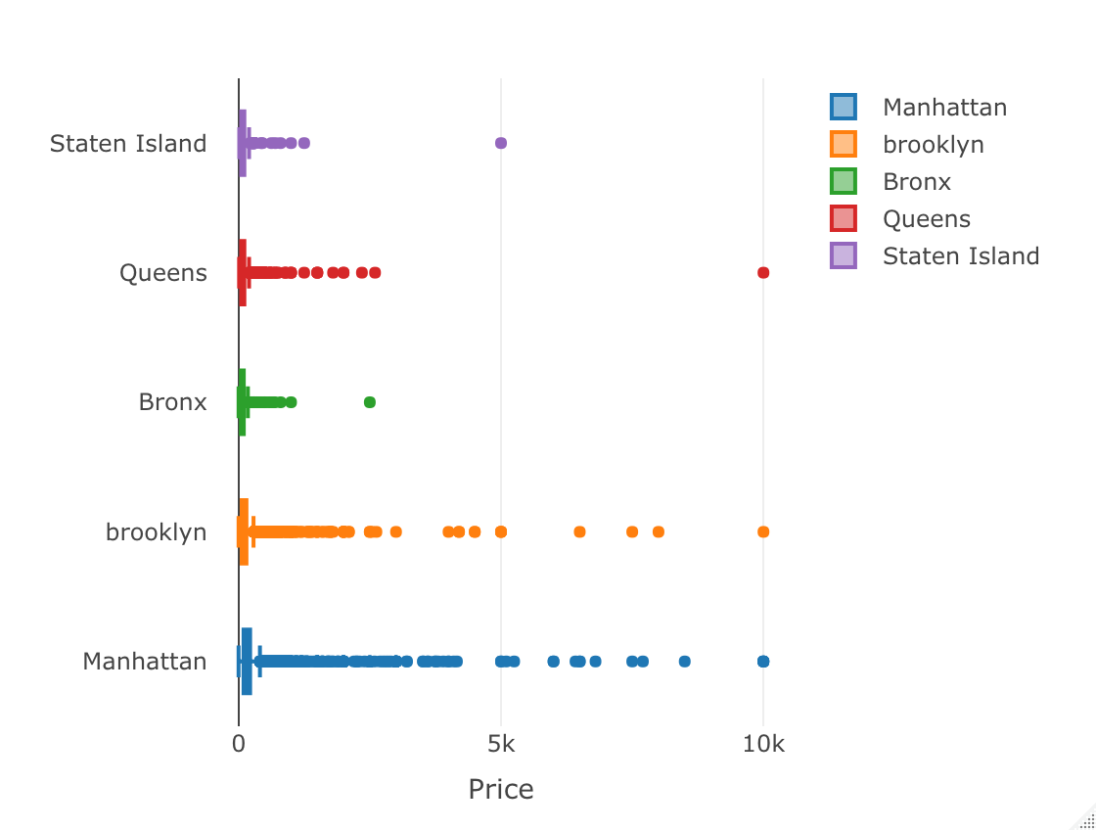

1. Comparation of the relationship between price, minimum night, number of reviews
2. Pairs diagram of the combination of the relationship of three variables



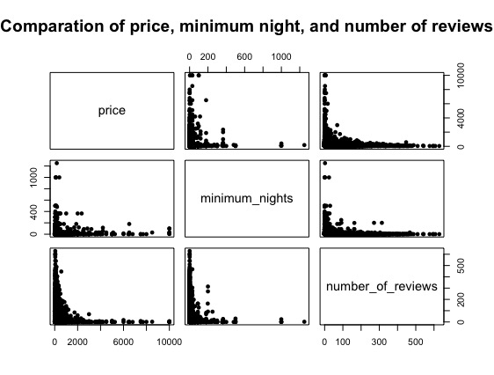

From the diagram above could clearly do the comparation to each two of the variables. There are three results could be determined.

SWOT ANALYSIS

Firstly, by compared of price and minimum_nights. More minimum nights need, lower price will be offered. And converse to be true that higher price gives less need of minimum nights.

Additionally, for price and number_of_reviews. More number of reviews, then the price gets lower. Conversely, higher price gets a smaller number of reviews.

Last but not least, for minimum_nights and number_of_reviews. More number of reviews implies fewer minimum nights. Moreover, more minimum nights needed, a smaller number of reviews provided.

1. Scatterplot of the relationship of price and minimum nights

For a better vision of the relationship between price and minimum nights. There will be a scatterplot for this relationship to prove the result, and provide a better vision.

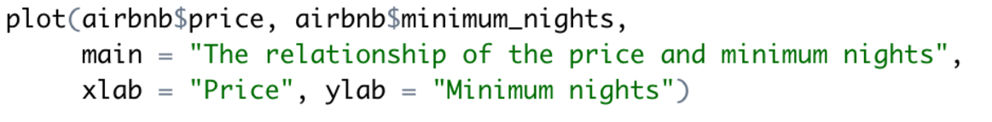

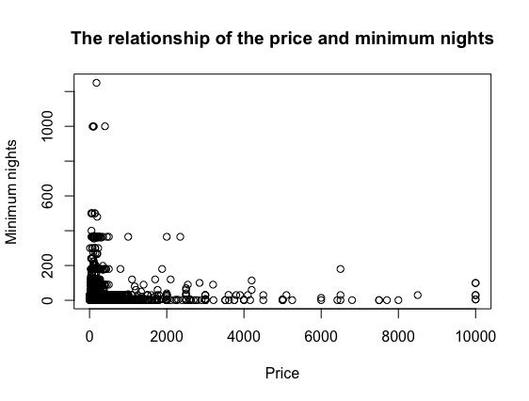

From the scatterplot showed above, the relationship between price and minimum nights is that higher price offered, fewer minimum nights needed. Which is as same as the result determined in the pairs diagram above.

1. Scatterplot for relationship of price and number of reviews

For the same reason, in order to provide a better vision of the relationship of price and number of reviews. By using plot() to provide a scatterplot to prove the result.

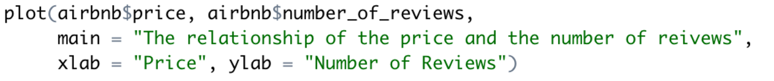

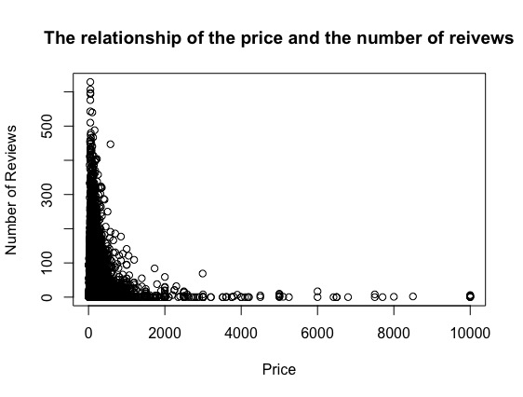

From the scatterplot, which clearly show the relationship that higher price implies a smaller number of reviews. Which proved the results.

1. Boxplots of price, minimum nights, and number of reviews

Applying the combination of boxplots of these three data to see their statistical number.



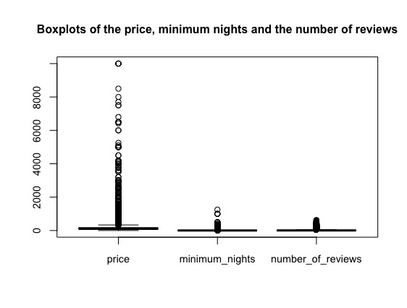

1. Distribution Analysis
2. Plotting the data of number of reviews in airbnb open data

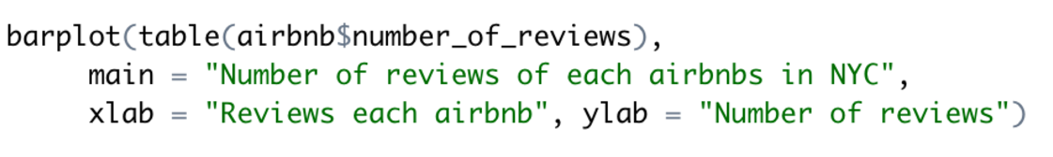

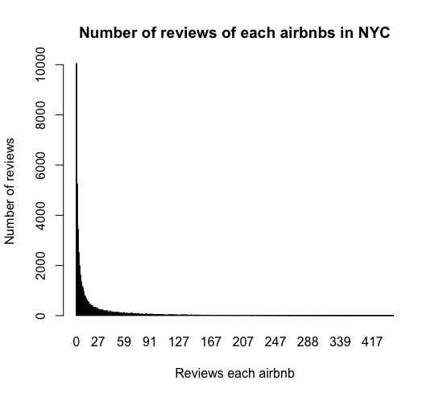

This plots clearly shows most of airbnbs has the number of reviews between 0 to 27.

1. Scatterplot for the probability of each number of reviews appeared

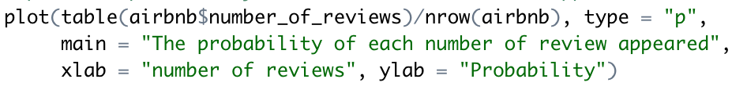

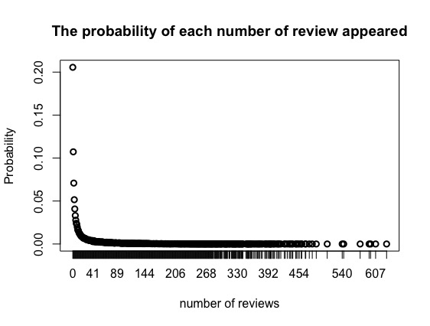

This scatterplot shows the probabilities of the number of reviews got by each airbnb. It is less possible to get more reviews.

1. Boxplot for the number of reviews



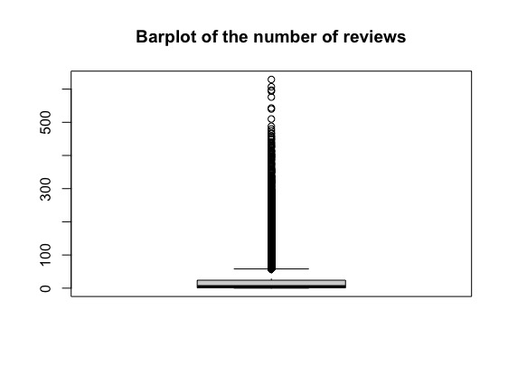

Using boxplot to show the statistical information for the numerical column number_of_reviews.

1. Summary of the number of reviews and its standard deviation

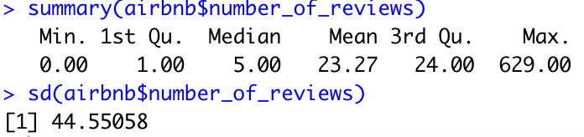

This is the six statistical number and standard deviation of number_of_reviews by using summary() and sd() functions.

1. Probability density function for the number reviews as normal distribution

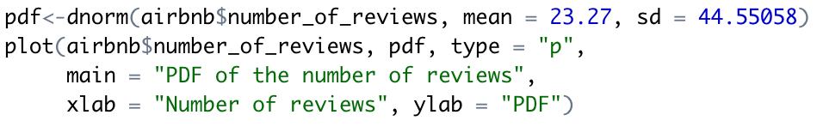

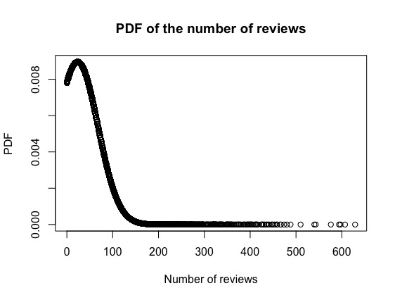

From the diagram of the probability density function, it could imply that more probabilities concentrated on [0,300], and the density is increasing from 0 to 600. As a result, an airbnb has a higher probability to receive fewer reviews.

1. Cumulative distribution function for the number reviews as normal distribution

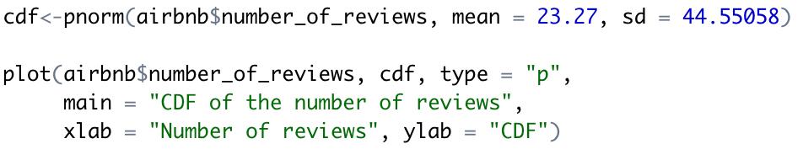

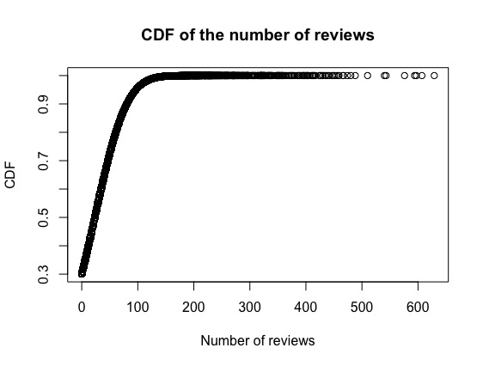

From above diagram, it could come up with the same result of PDF, which is with the increasing number of reviews, the probability is decreasing declining significantly. With the decreasing of the slope, the probability is decreasing. Also, the density is decreasing with the increasing number of reviews.

1. Applicability of the Central Limit Theorem for Price
2. Setting data

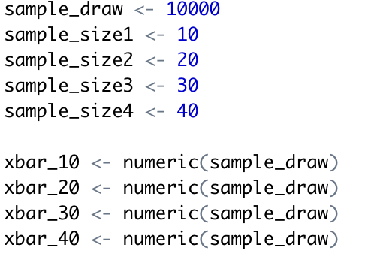

Setting the data for central limit theorem. In this part, 4 different sample size 10, 20, 30, 40 will be used for each one method to do the data visualization for price of the whole NYC, and for each borough. 10000 samples will be draw randomly with replacement and equal probability.

1. Central Limit Theorem visualization for price

* Histogram for CLT of sample size 10, 20, 30, 40 for price

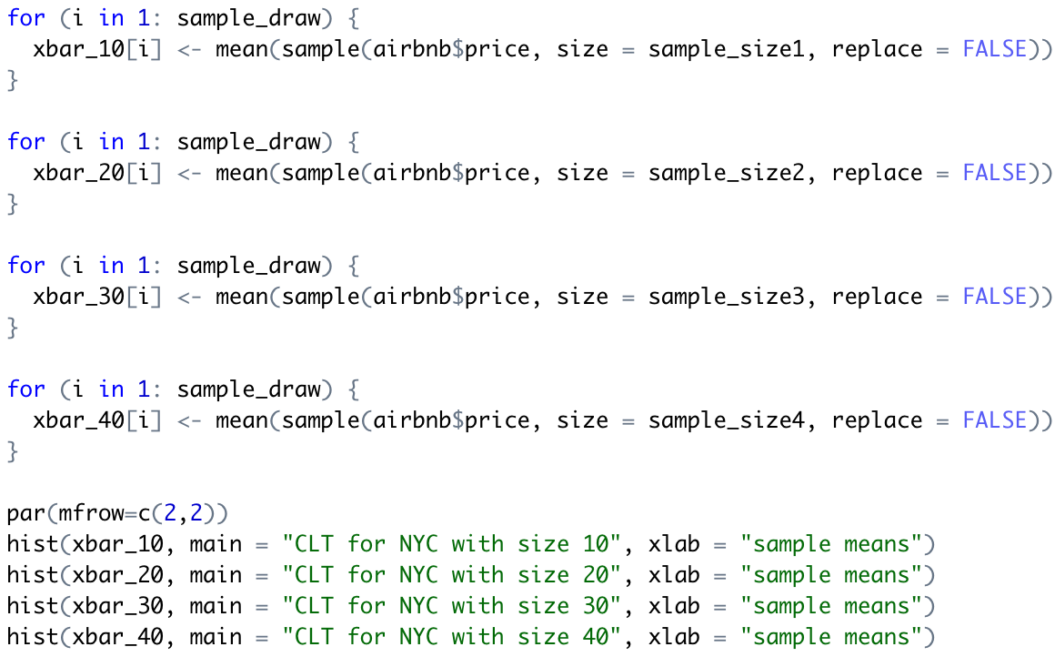

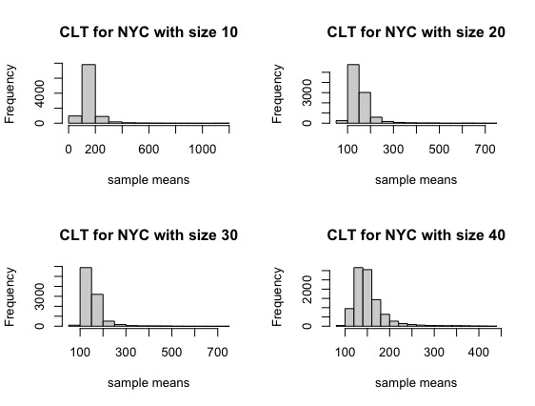

With each sample size, the means are all focus on 100 to 200. From the diagram, it could be determined that the price column is a right-skewed diagram. From the large data set airbnb, the sample means are normal distributed. And it is normal distributed in all four sample sizes. Next step, applying central limit theorem to each borough and doing data visualization for each one.

1. Central Limit Theorem visualization for each borough

* CLT for Manhattan

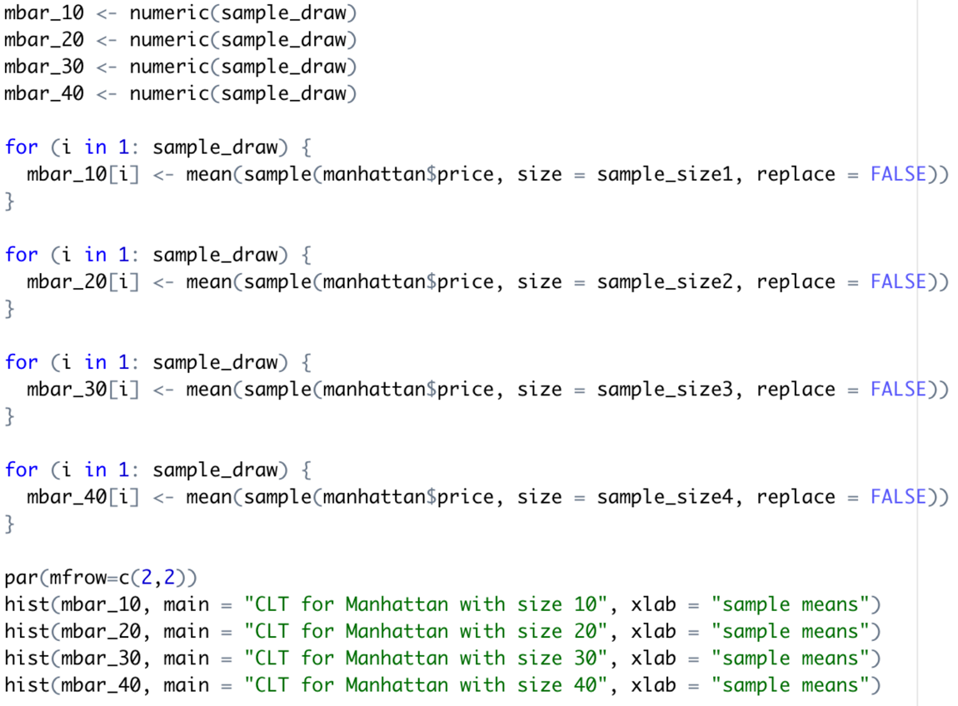

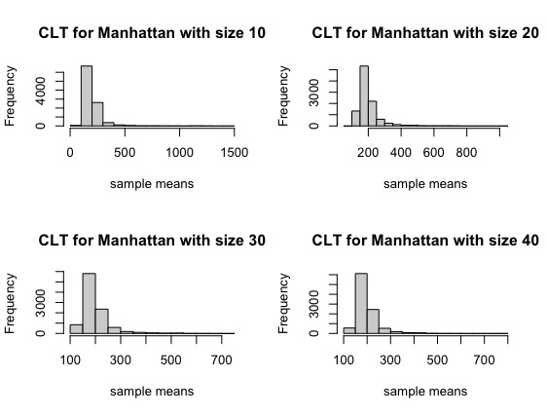

* CLT for Brooklyn

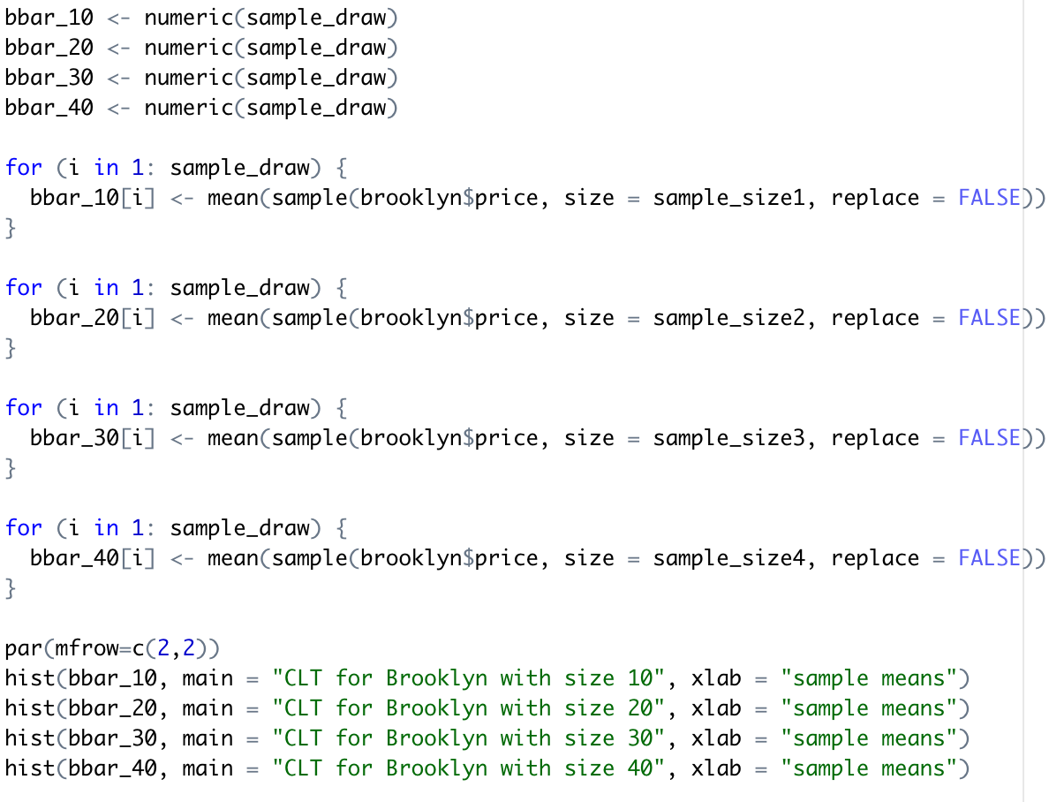

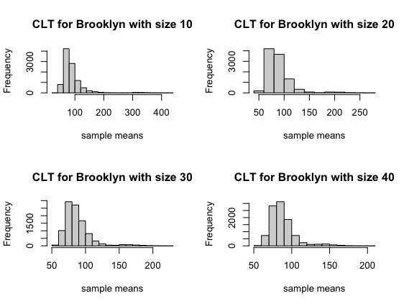

* CLT for Bronx

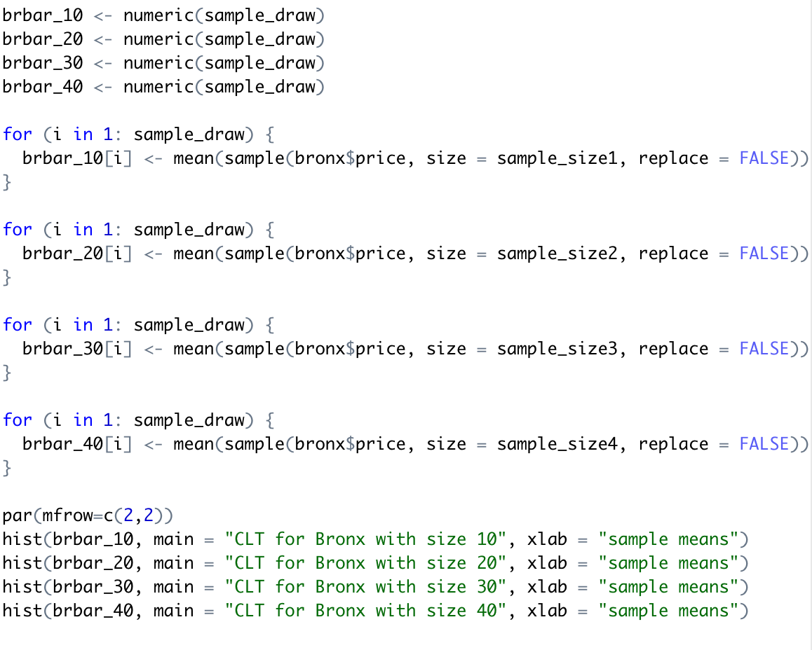

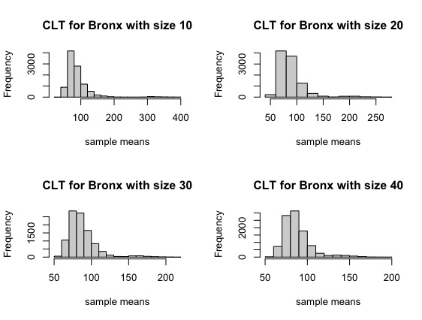

* CLT for Queens

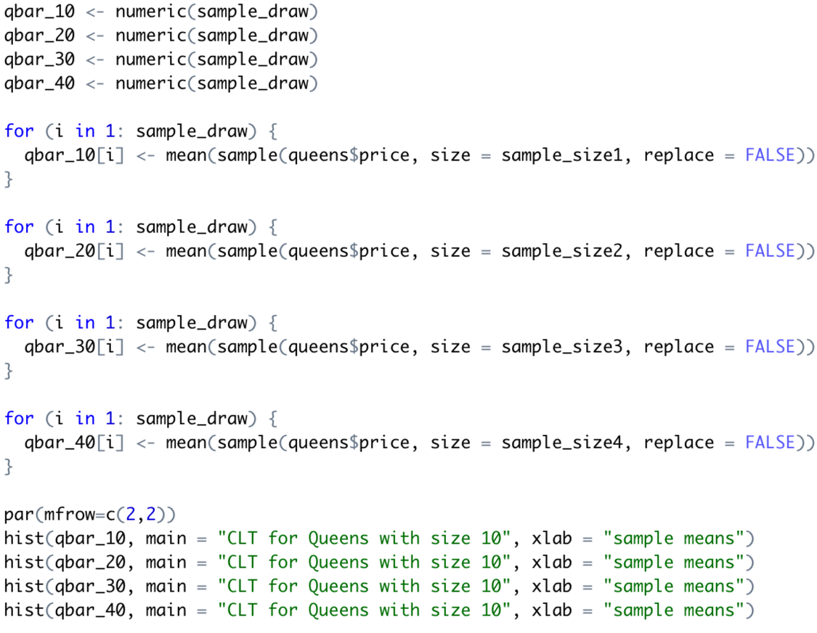

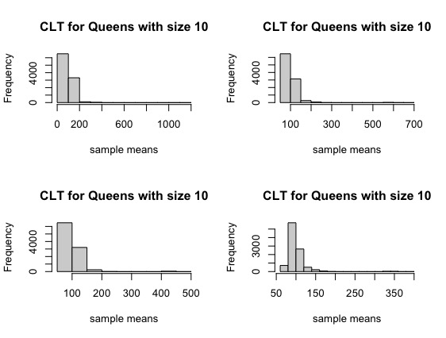

* CLT for Staten Island

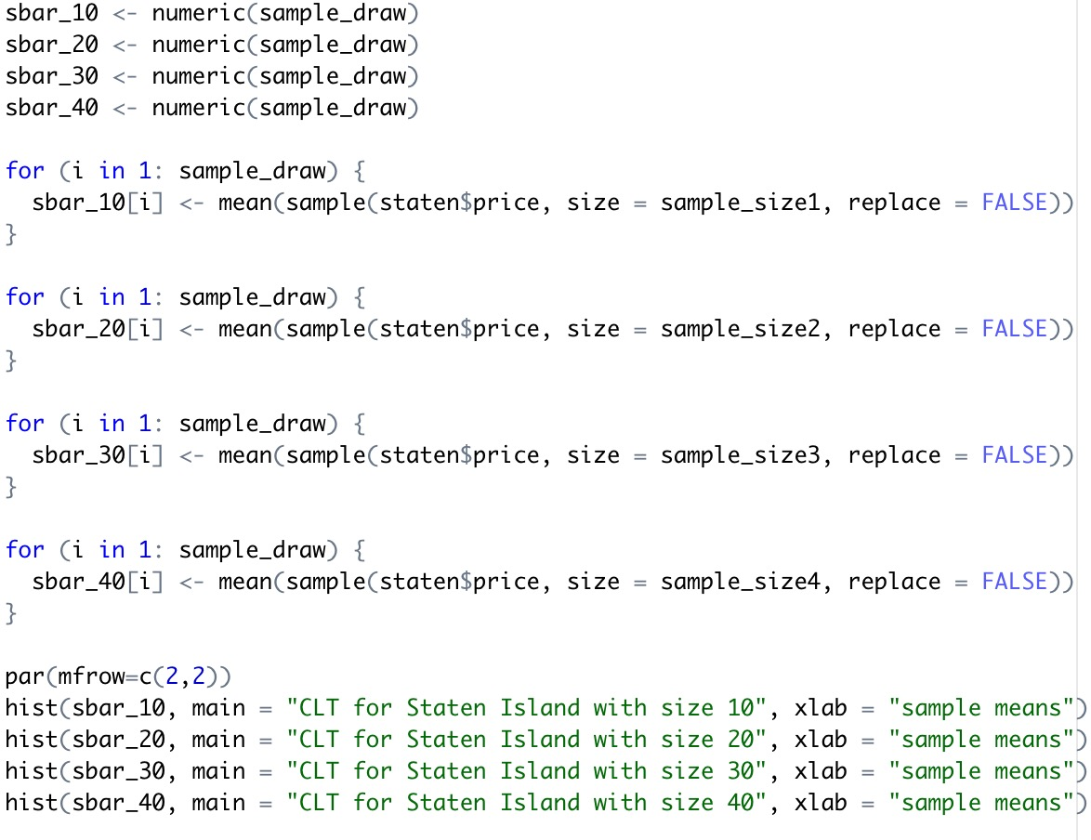

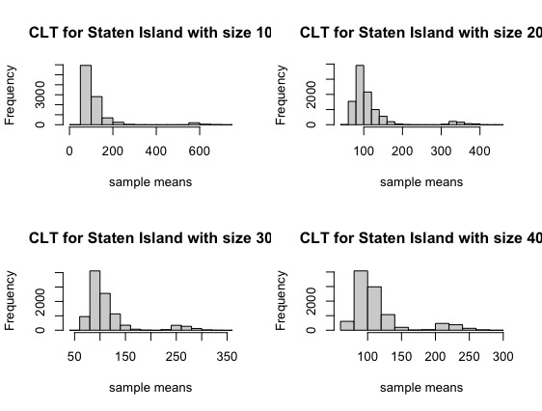

1. Sampling for airbnb open data
2. Setting data

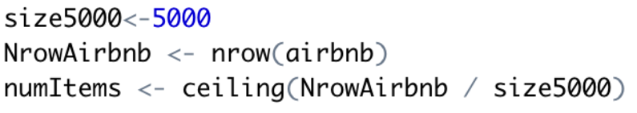

Randomly draw 5000 samples from the whole airbnb data set by using sampling method to draw different samples.

1. Sample random sampling

* Table of 5000 random variables drew in Airbnb

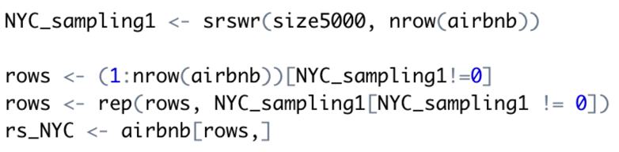

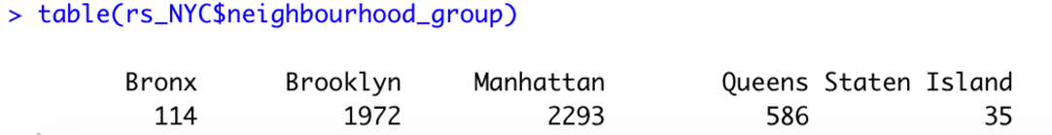

By using sample random sampling, 5000 samples were drawing. By table() function, it shows that 114 samples from Bronx, 1972 samples from Brooklyn, 2293 samples from Manhattan, 586 samples from Queens, and 35 samples from Staten Island.

* Barpolot of 5000 random variables drew in airbnb

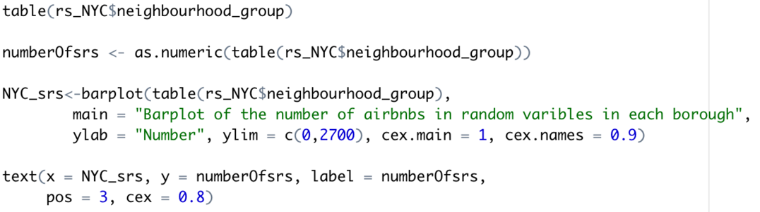

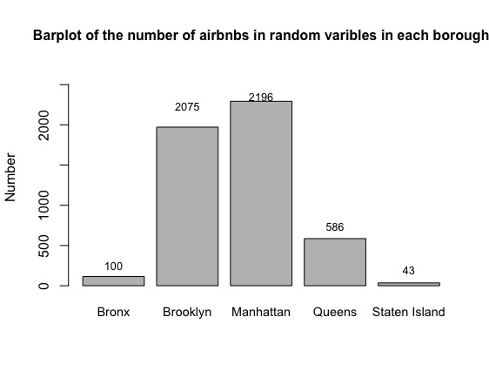

Doing the data visualization for the samples drew by sample random sampling.

* Table of proportion of random variables drew in each borough

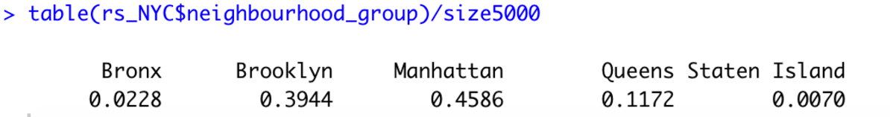

Now, calculate the proportion of sampling drew from each borough by using table(). Next, using pie chart to see a better version of the data.

* Pie chart of the proportion of random variables drew in each borough

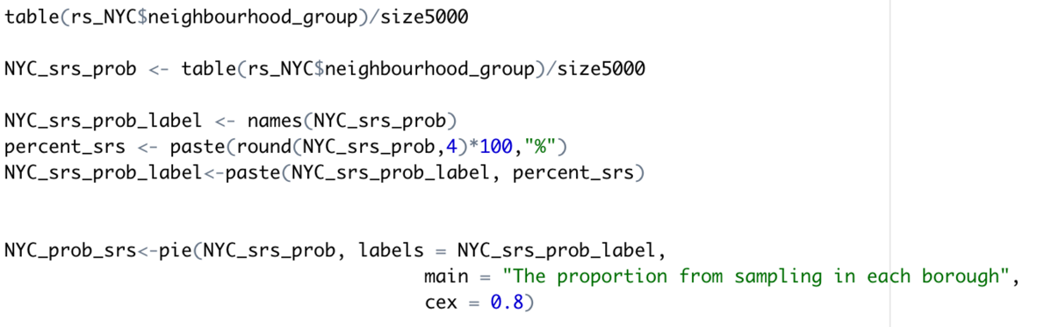

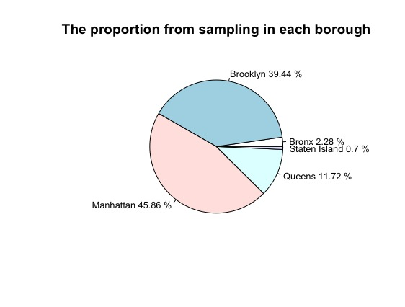

From the pie chart shows Manhattan occupied 45.86% of 5000 samples, which is the most. Brooklyn has the second the greatest number of samples and occupied 39.44%. Queens is the next occupied 11.72%. Bronx stands 2.28%. Staten Island has the least number of samples out of 5000, and it stands for 0.7%.

1. Systematic sampling

* Table of systematic sampling with size = 5000 for each borough

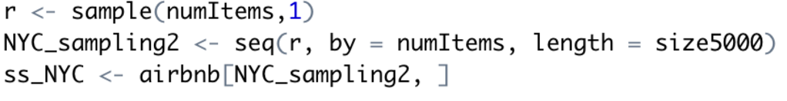

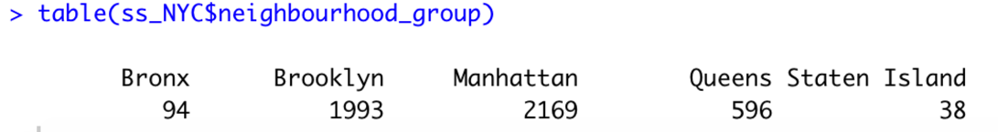

By using systematic sampling to draw 5000 samples form airbnb data set. The table shows 94 samples from Bronx, 1993 from Brooklyn, 2169 from Manhattan which is the biggest, 596 samples from Queens, and only 38 sample from Staten Island, which is the least one.

* Barplot of systematic sampling with size = 5000 for each borough

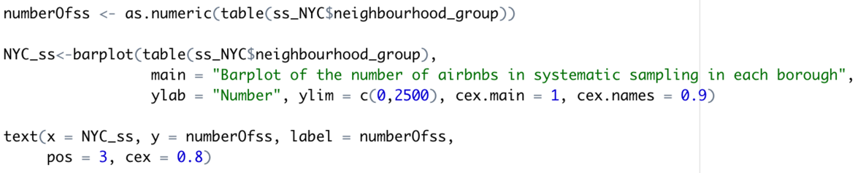

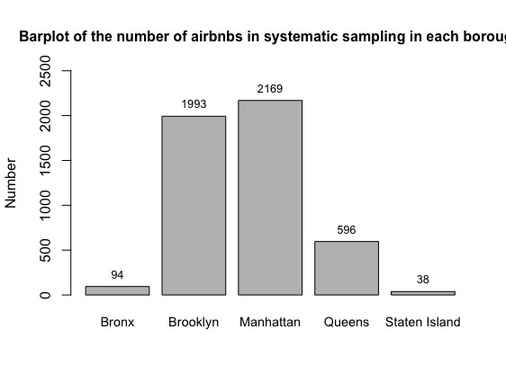

Using barplot to show the number of samples drew from each borough could also show Manhattan has the most samples and Staten Island has the least samples.

* Table of the proportion of systematic sampling with size = 5000 for each borough

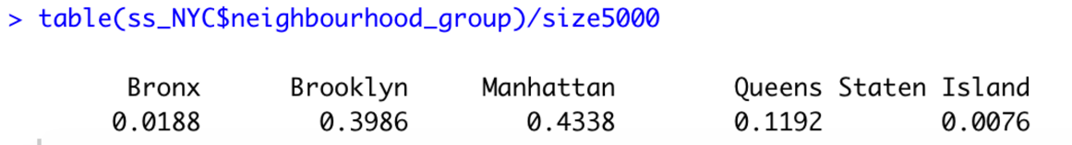

Calculating the proportion of the samples drew by systematic sampling of each borough. Moreover, doing pie chart again to see the clearly proportion of samples in each borough.

* Pie chart for the proportion of systematic sampling with size = 5000 for each borough

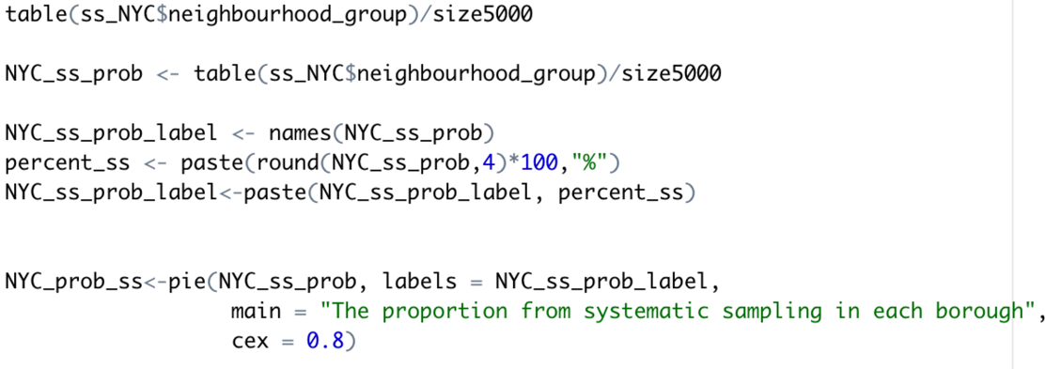

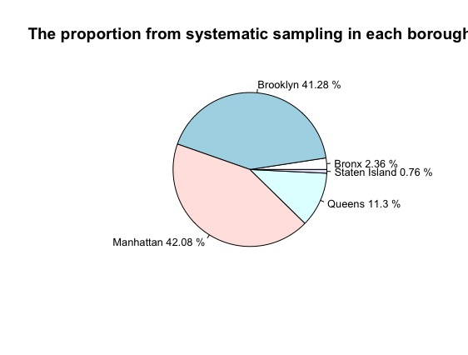

From the pie chart above, it shows Manhattan has 42.08% of 5000 samples, which has the most samples. Brooklyn has the second the greatest number of samples and occupied 41.28%. Queens is the next has 11.3%. Bronx has 2.36%. Staten Island has the least number of samples out of 5000, it only has 0.76%.

1. Inclusion probability

* Table of inclusion probability

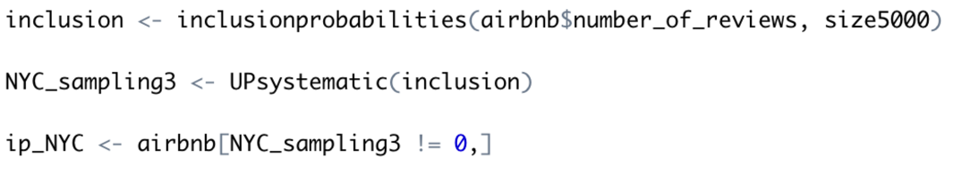

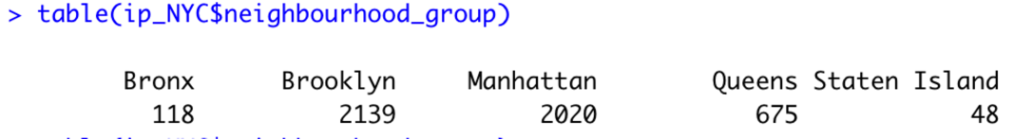

For inclusion probability, drawing 5000 samples. 118 samples from Bronx, 2139 sample from Brooklyn, 2020 samples from Manhattan, 675 samples from Queens, and 48 samples from Staten Island.

* Barplot of inclusion probability

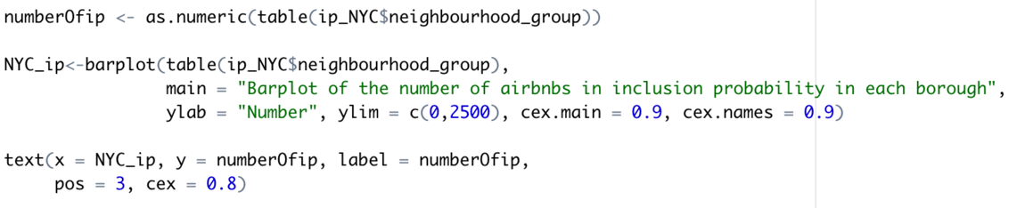

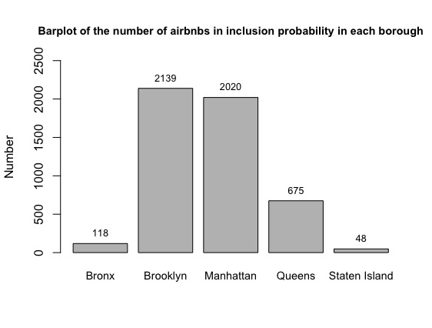

From the diagram, Brooklyn has the most samples this time, Manhattan has the second the greatest number of samples. Staten Island still has the least number of samples.

* Table of the proportion of inclusion probability of the number of airbnbs

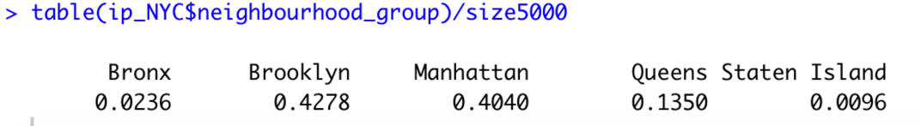

* Pie chart for the proportion of inclusion probability of the number of airbnbs

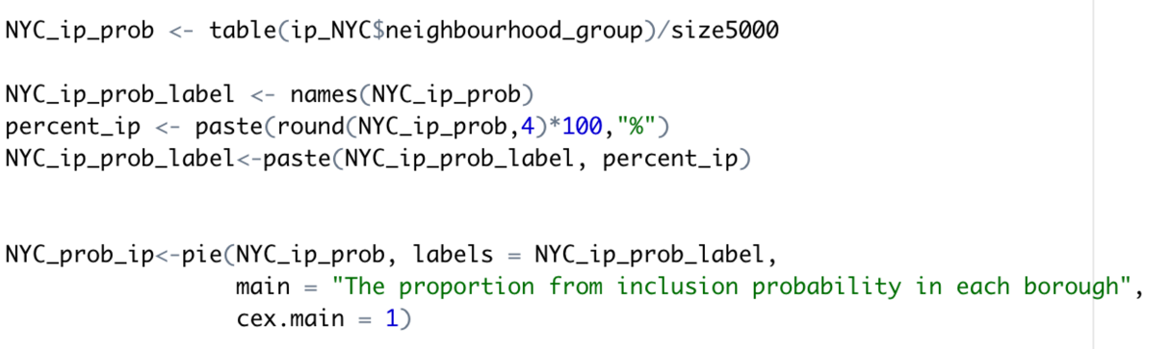

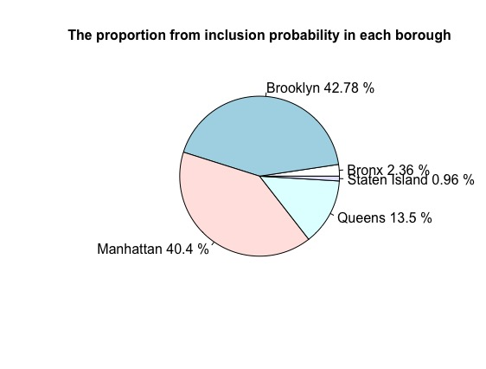

From the pie chart above, it shows Manhattan has 40.4% of 5000 samples, which has the second most samples this time. Brooklyn has the second the greatest number of samples and occupied 42.78%, which has the greatest number of samples this time. Queens is the next has 13.5%. Bronx has 2.36%. Staten Island still has the least number of samples out of 5000, it only has 0.96%.

1. Stratified

* Setting data

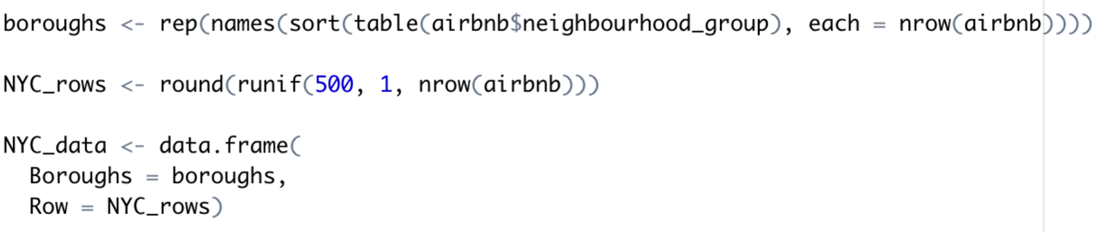

* Table and description of stratified data

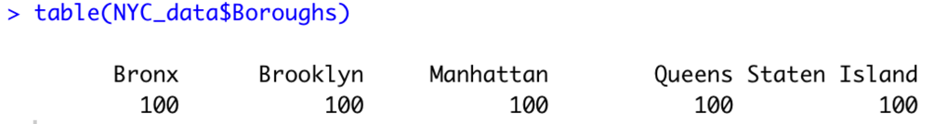

* Strata function for airbnb open data with 500 sample size

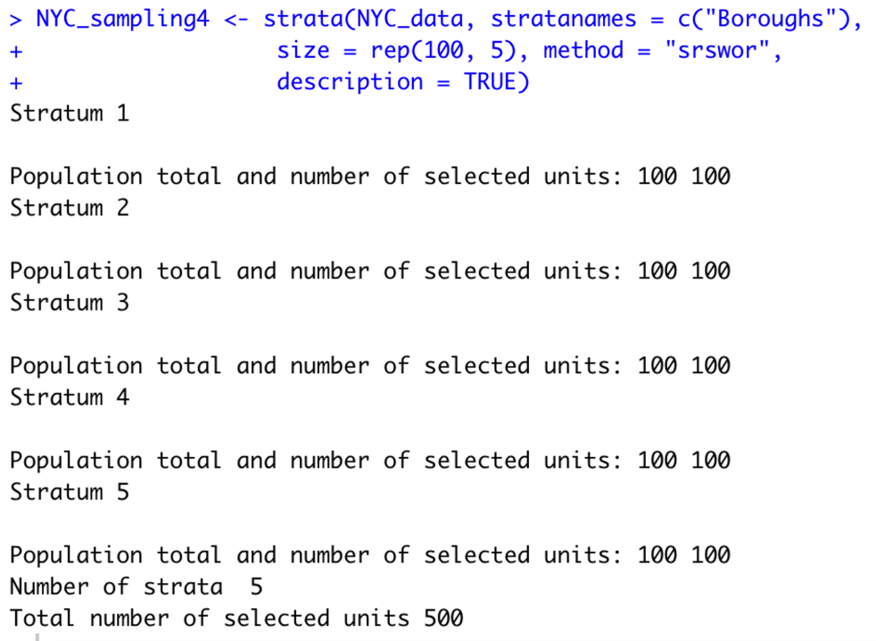

These sampling could help researchers to save their times and obtain a reliable result. Without sampling, researchers need to spend a lot of time to get the data from real-time data. By using sampling, researchers could do the data analysis and expect the future result. In this project, the sample size is 10000 and 5000 which provide the idea that if there are 5000 or 10000 customers are looking for an airbnb to stay, which price interval they probably choose. And it could help the company gets an accurate result because random variables simulated the number of real customers. The company could clearly see the mean, standard deviation and based on different variable such as price or number of reviews which one they choose the most. Applying these samples to the whole dataset will not provide an expectation, it shows the regular analysis.

1. Means comparison of price

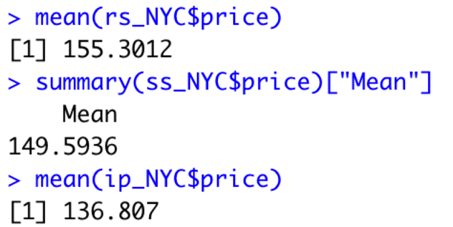

**Conclusion**

The goal of this project is to show and determine three information, three relationships and sampling for the data. Three information that need to be determined is:

1. How many airbnbs in each borough, which has the most and which has the least?
2. Which borough has the highest price and which has the lowest?
3. What are their proportions?

For the first one, from first part of the project, we can know that there are 1091 airbnbs in Bronx, 20104 airbnbs in Brooklyn, 21661 airbnbs in Manhattan, 5666 airbnbs in Queens, and 373 airbnbs in Staten Islands. Secondly, Manhattan has the largest number of airbnbs which is 21661. Staten Island has the least number of airbnbs which is 373. Eventually, Manhattan occupied the most percentage of the number of airbnbs which is 44.3%. Brooklyn is NO.2 which has 41.12%. Queens has 11.59%. Bronx has 2.23%. And Staten Island has the least percentage, which is 2.23%.

The three relationships that this project want to explore is:

1. The relationship between price and number of reviews.
2. The relationship between price and minimum nights
3. The relationship between number of reviews and minimum nights.

For these three relationships, from pairs diagram. More minimum nights need, lower price will be offered. And converse to be true that higher price gives less need of minimum nights. In addition, a greater number of reviews, then the price gets lower. Conversely, higher price gets a smaller number of reviews. Lastly, for minimum_nights and number_of_reviews. More number of reviews implies fewer minimum nights. Moreover, more minimum nights needed, a smaller number of reviews provided.

From distribution analysis, it is less possible to get more reviews. The probability is decreasing. From the diagram of the probability density function, it implies that more probabilities concentrated on [0,300], and the density is increasing from 0 to 600. As a result, an airbnb has a higher probability to receive fewer reviews. From cumulative density function, the increasing number of reviews, the probability is decreasing declining significantly. With the decreasing of the slope, the probability is decreasing. Also, the density is decreasing with the increasing number of reviews.

Applying central limit theorem to the whole data set and each borough, it could be determined that the price column is a left-skewed diagram. From the large data set airbnb, the sample means are normal distributed. And it is normal distributed in all four sample sizes. Next step, applying central limit theorem to each borough and doing data visualization for each one.

Four sampling methods used in this project, sample random sampling, systematic sampling, inclusion probability, and strata. Generating 5000 samples from the whole airbnb data set. By comparing the mean of the first three sampling methods, the means are decreasing a little.

**References**

D. (2019, August 12). *New York City Airbnb Open Data*. Kaggle. https://www.kaggle.com/dgomonov/new-york-city-airbnb-open-data?select=AB_NYC_2019.csv

Kalathur, S. (2020, October 7). *CS 544 Module 5*. BU CS544. <https://onlinecampus.bu.edu/bbcswebdav/pid-7953809-dt-content-rid-40368175_1/courses/20fallmetcs544_o1/course/module5/allpages.htm>

Kalathur, S. (2020, September 30). *CS 544 Module 4*. BU CS544. https://onlinecampus.bu.edu/bbcswebdav/pid-7953808-dt-content-rid-40368145_1/courses/20fallmetcs544_o1/course/module4/allpages.htm

Kalathur, S. (2020, September 23). *CS 544 Module 3*. BU CS544. https://onlinecampus.bu.edu/bbcswebdav/pid-7953807-dt-content-rid-40368122_1/courses/20fallmetcs544_o1/course/module3/allpages.htm